Template module 2.9 Advertisement template for international volunteering to communicate
Objective: Prepare a complete, realistic and accessible opportunity before publication. When: Before recruitment. Completed by: Coordinator with the relevant team. Evidence to be kept: Final version approved and publication record.

International Volunteering | Europe
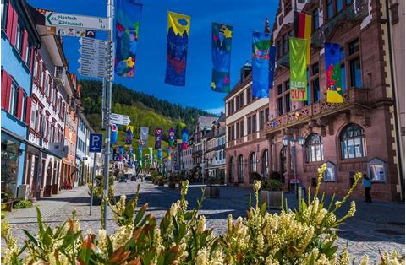
Do you want to do International Volunteering in Europe? This opportunity is for you!

A Volunteering opportunity is open at the XXX organization, Portugal
For whom? Young volunteers from 18 to 30 years old*
What tasks? Volunteers will have the opportunity to collaborate in various tasks
Project 1 - Residential Home for the Elderly: The volunteer will be able to collaborate in different activities, focused on supporting the elderly in vulnerable situations
Project 2 - Citizens' Association: The volunteer will be able to collaborate in different activities, focused on responding to emerging social needs, as well as emergency situations, through a joint action
Duration? 10 / 12 months, to be started as soon as possible
Where? Project 1 - XXX | Project 2 - YYYY
Want to participate? Send us your CV and motivation letter to organizacao@organizacao.com
If you have any questions, contact us!
924 145 871
Registration until the xxxx, here:

Note: Adopt to the type of commitment. Read information in module 2.

